**Case Priority**

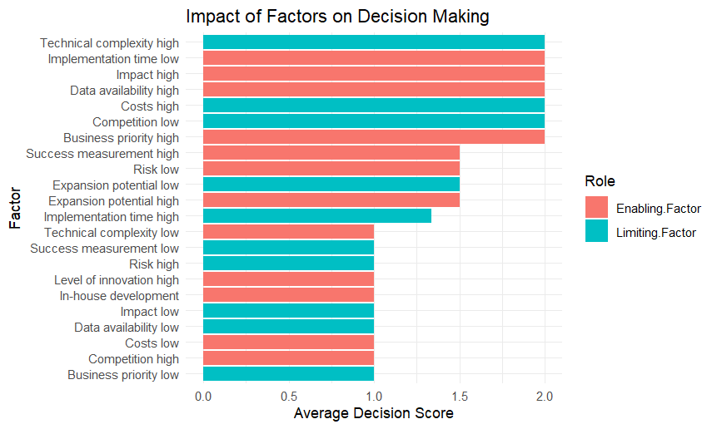

**1. Top Influential Factors**

**Technical complexity high (Limiting):** Major barrier due to high complexity.

**Implementation time low (Enabling)**: Quick implementation is desirable but may introduce trade-offs.

**Impact high (Enabling)**: Strongly encourages implementation.

**Data availability high (Enabling):** Supports decision-making when data is available.

**Costs high (Limiting):** High costs discourage implementation.

**Competition low (Enabling):** Low competition reduces risks and encourages decisions.

**2. Positive vs. Negative Influences**

Enabling Factors (Red): Support decisions (e.g., "Impact high," "Business priority high").

Limiting Factors (Teal): Hinder decisions (e.g., "Technical complexity high," "Costs high").

**3. Dual-Role Factors**

Some factors can be both enabling and limiting:

Expansion potential: High enables, low limits.

Impact: High enables, low limits.

Data availability: High enables, low limits.

**4. Less Influential Factors**

Factors like "Business priority low" and "Costs low" have minimal impact and can be deprioritized.

**Key Takeaways**

**Reduce barriers:** Address technical complexity and high costs.

**Leverage enablers:** Focus on high impact, quick implementation, and strategic alignment.

**Context matters:** Some factors (e.g., data availability) can be both enabling and limiting.

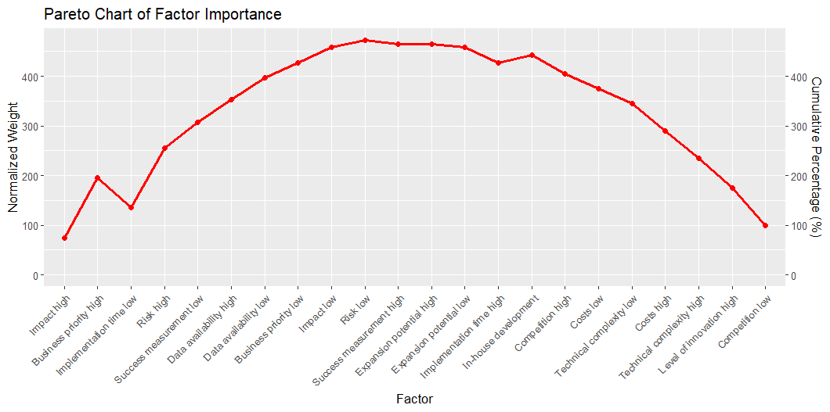

**1. X-Axis (Factor):**

* Represents factors affecting decision-making (e.g., "Impact high," "Business priority high," "Implementation time low").
* Sorted from most to least important.

**2. Left Y-Axis (Normalized Weight):**

* Shows the individual impact of each factor.
* Indicates how much each factor contributes to decision-making.

**3. Right Y-Axis (Cumulative Percentage %):**

* Represents the cumulative effect of factors from left to right.
* The red line visualizes the cumulative percentage, highlighting the 80/20 rule (Pareto Principle).

**Key Insights:**

* The first few factors contribute the most to decision-making.
* The red line rises sharply initially, indicating that a small number of factors have the greatest impact.
* The curve flattens as more factors are added, showing diminishing returns.
* Prioritize the top factors to achieve the most significant improvements.

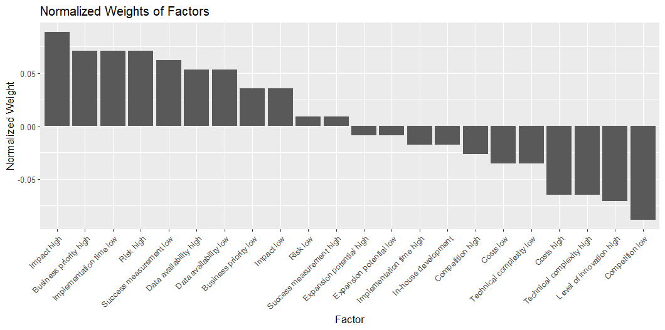

**1. Chart Overview**

* **X-Axis:** Factors influencing decisions.
* **Y-Axis (Normalized Weight):**
  + **Positive (left):** Factors that enable decisions.
  + **Negative (right):** Factors that hinder decisions.

**2. Key Observations**

**Top Enablers:**

1. **Impact high:** Drives decisions.
2. **Business priority high:** Aligns with goals.
3. **Implementation time low:** Quick execution preferred.

**Top Barriers:**

1. **Technical complexity high:** Major hurdle.
2. **Costs high:** Deters decisions.
3. **Competition low:** Less attractive.

**Neutral Factors:**

* **Success measurement high, Risk low, Expansion potential high:** Context-dependent.

**3. Actionable Takeaways**

* **Focus on:** High-impact, business-aligned, quick-to-implement projects.
* **Reduce:** Complexity and costs.
* **Balance:** Innovation with feasibility.

|  |  |  |  |  |  |  |
| --- | --- | --- | --- | --- | --- | --- |
| Summary of Factor Importance | | | | | | |
| Prioritization of Use Case Factors | | | | | | |
| **Factor** | **Frequency** | **Sum (1)** | **Sum (0)** | **Weighted Importance** | **Normalized Weight** | **Cumulative %** |
| **Impact high** | 2 | 20 | 0 | 10 | 0.09 | 75 |
| **Implementation time low** | 1 | 9 | 1 | 8 | 0.07 | 135 |
| **Business priority high** | 1 | 9 | 1 | 8 | 0.07 | 195 |
| **Risk high** | 1 | 9 | 1 | 8 | 0.07 | 255 |
| **Success measurement low** | 2 | 17 | 3 | 7 | 0.06 | 307.5 |
| **Data availability high** | 2 | 16 | 4 | 6 | 0.05 | 352.5 |
| **Data availability low** | 1 | 8 | 2 | 6 | 0.05 | 397.5 |
| **Business priority low** | 1 | 7 | 3 | 4 | 0.04 | 427.5 |
| **Impact low** | 1 | 7 | 3 | 4 | 0.04 | 457.5 |
| **Success measurement high** | 2 | 11 | 9 | 1 | 0.01 | 465 |
| **Risk low** | 2 | 11 | 9 | 1 | 0.01 | 472.5 |
| **Expansion potential high** | 2 | 9 | 11 | −1.00 | −0.01 | 465 |
| **Expansion potential low** | 2 | 9 | 11 | −1.00 | −0.01 | 457.5 |
| **In-house development** | 1 | 4 | 6 | −2.00 | −0.02 | 442.5 |
| **Implementation time high** | 3 | 12 | 18 | −2.00 | −0.02 | 427.5 |
| **Competition high** | 2 | 7 | 13 | −3.00 | −0.03 | 405 |
| **Costs low** | 1 | 3 | 7 | −4.00 | −0.04 | 375 |
| **Technical complexity low** | 1 | 3 | 7 | −4.00 | −0.04 | 345 |
| **Costs high** | 3 | 4 | 26 | −7.33 | −0.07 | 290 |
| **Technical complexity high** | 3 | 4 | 26 | −7.33 | −0.07 | 235 |
| **Level of innovation high** | 1 | 1 | 9 | −8.00 | −0.07 | 175 |
| **Competition low** | 1 | 0 | 10 | −10.00 | −0.09 | 100 |

**Key Takeaways from the Analysis**

**Prioritize:**

High impact, business priority, quick implementation, and calculated risk—these drive successful use cases.

**Neutral Impact:**

Low risk and strict success measurement have minimal influence.

**Avoid:**

High costs, technical complexity, high innovation, and low competition these hinder prioritizations.

**Conclusion:**

Focus on high-impact, business-aligned, and fast-to-implement projects while minimizing complexity and costs.